COSC 455
Programming Languages: Design and Implementation
Fall 2025

Lab Exercise #7

The evolution of languages: FORTRAN is a non-typed language. C is a weakly typed language. Ada is a strongly typed language. C++ is a strongly hyped language.
- Ron Sercely

Name: / 5

Goals: The intention of this lab exercise is to reintroduce/emphasize the data type concepts that we briefly discussed in lecture on the materials from Chapters 7 & 8.

Language/Compiler: For this lab exercise, you may use one of the many online, C++ compilers/editors, such as http://www.tutorialspoint.com/compile_cpp_online.php, http://cpp.sh/, etc.). If you would like to use a standard C++ compiler (e.g., Visual Studio, Cygwin, etc.), that is also ok.

Deadline: Submitted via Blackbeard by Tuesday, November 11, 2025, 11:59pm.

Submission: The submission of this lab exercise will be in two parts: The written portion of this lab exercise should be submitted in a single source file (i.e., *.docx, *.odt, *.txt, etc.) with a naming convention of FirstNameLastNameLab5. For example, if your name is Homer Simpson, you would have a file named HomerSimponLab5.doc. Lab submissions not following this convention may not be graded.

1. Data Types in C++. (5 points) Download the Question1.cpp file from Blackboard. Complete the program as described in the comments using your C++ of choice and provide your code and a screenshot of the output here.
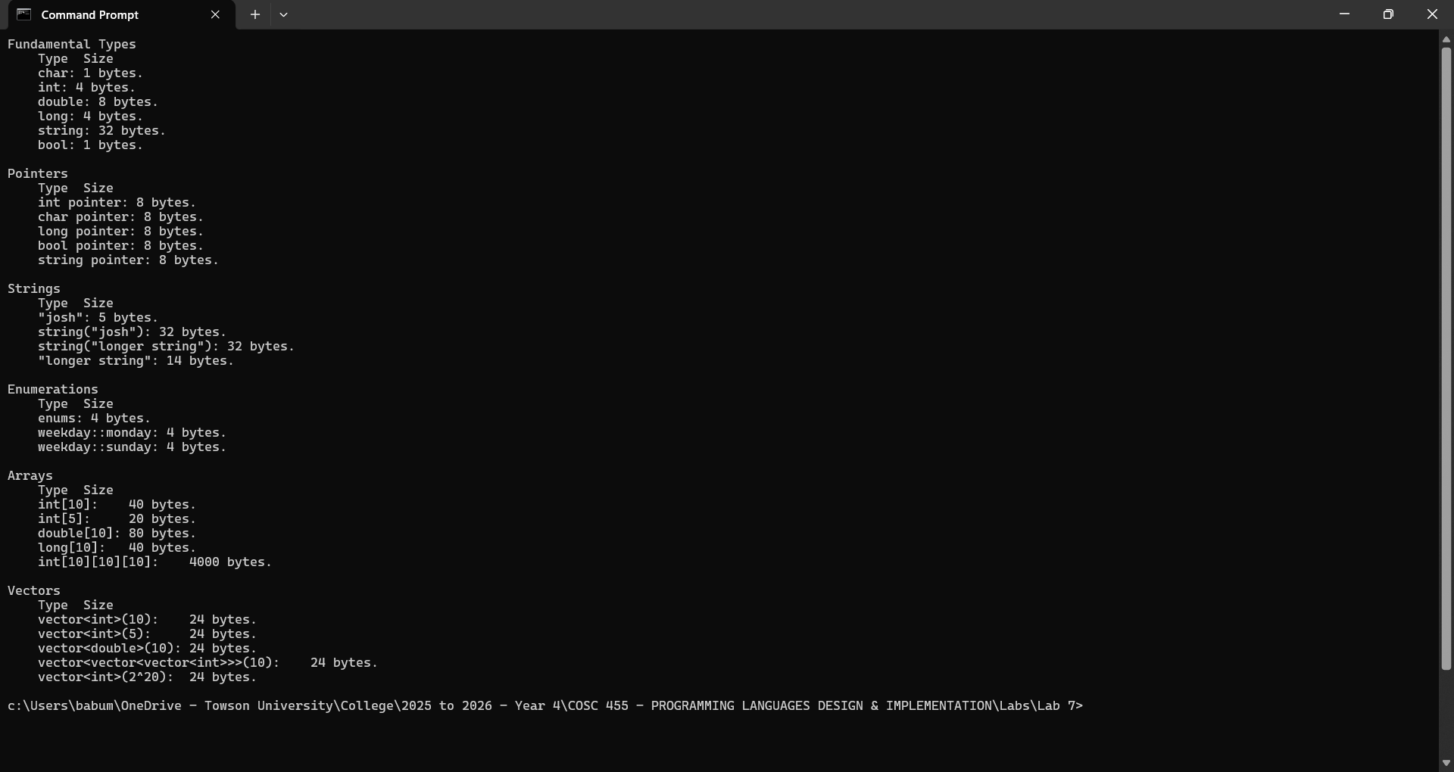

In addition, to demonstrate what you have learned about C++ data types that, at a minimum, includes specific examples and answers the following questions:
- Do all pointer types need the same storage? Why/why not?
  - No. The pointer variable just stores a memory address so no matter the type of pointer it is it will be the same size but the types that it points to have unique sizes.
- Does the size of a pointer reflect the size of the data type it is pointing to? No
- Does the size of an enum differ with the number of elements? Why/why not?
  - No because enums are int by default so they are the same size as an int unless you change it to another number type .
  - I am guessing that in c++ enums work like how const works in rust; when u call an enum value its like inlined so its not actually in memory.
- Does the size of an array differ with the number of elements? Why/why not?
  - Yes Because arrays don’t change in size so when its created the amount of bytes needed for that array can be known from the size it is created with.
- Does the size of a vector differ with the number of elements? Why/why not?
  - No. I believe it is because vectors grow and shrink as the program is running and using sizeof on it just gives the size of the vector object
- What is the reason for the difference in how much memory is allocated for strings?
  - I believe it is because a string is an array of characters that can dynamically change in size.
- In your experience, which data types does C++ store in the stack and which in the heap?
  - In my experience I believe that in C++ any datatype created with new() is stored on the heap and needs to be manually freed while anything not created with new() is on the stack and freed when its out of scope and dynamically resizing types like vector and string
Finally, copy and paste this code into the C++ 4.3.2 compiler at www.ideone.com. How does the output differ? If the output differs, describe why this is the case.
  - The difference in output was that long and double are now both 8 bytes.
  - It is because the compilers are not the same.

Note: There are 2-5 Easter eggs (this isn’t one of them) in this lab. If you find one, let me know!

